Question 1:

include <stdio.h>

int main(){

char a1,a2,a3;

int vowels=0,consonants=0;

printf("Enter first alphabet: ");

scanf(" %c", &a1);

printf("Enter second alphabet: ");

scanf(" %c", &a2);

printf("Enter third alphabet: ");

scanf(" %c", &a3);

if (a1=='a'||a1=='e'||a1=='i'||a1=='o'||a1=='u'||a1=='A'||a1=='E'||a1=='I'||a1=='O'||a1=='U')

vowels++;

else

consonants++;

if (a2=='a'||a2=='e'||a2=='i'||a2=='o'||a2=='u'||a2=='A'||a2=='E'||a2=='I'||a2=='O'||a2=='U')

vowels++;

else

consonants++;

if (a3=='a'||a3=='e'||a3=='i'||a3=='o'||a3=='u'||a3=='A'||a3=='E'||a3=='I'||a3=='O'||a3=='U')

vowels++;

else

consonants++;

printf("\nTotal number of vowels:%d\n",vowels);

printf("Total Consonants: %d\n",consonants);

return 0;

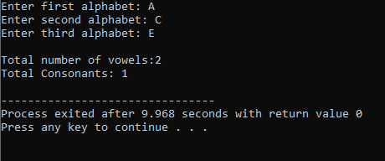

Question3:

#include <stdio.h>

int main(){

int x=7,y=4,z=5;

// the operations are performed from highest to lowest precedence

int step1=x\*y;

printf("Step 1: y \* z = %d\n", step1);

int step2=x+step1;

printf("Step 2: x + y\*z = %d\n", step2);

int step3=step2>10;

printf("Step 3: (x + y\*z > 10) = %d\n", step3);

int step4=x-z;

printf("Step 4: x - z = %d\n", step4);

int step5=step4<y;

printf("Step 5: (x - z < y) = %d\n", step5);

int step6=y%z;

printf("Step 6: y %% z = %d\n", step6);

int step7=!(step6);

printf("Step 7: !(y %% z) = %d\n", step7);

int step8=step3 && step5;

printf("Step 8: (step3 && step5) = %d\n", step8);

int step9=step8||step7;

printf("Step9: %d\n", step9);

return 0;

}

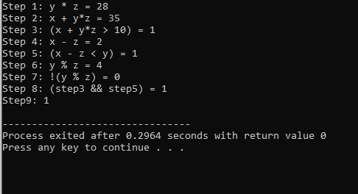

Question 6:

#include <stdio.h>

void printBinary(int n){

printf("%d%d%d%d%d%d%d%d",

(n >> 7) & 1,

(n >> 6) & 1,

(n >> 5) & 1,

(n >> 4) & 1,

(n >> 3) & 1,

(n >> 2) & 1,

(n >> 1) & 1,

n & 1

);

}

int main(){

int a=73;

int b=46;

int andresult= a & b;

int xorresult=a ^ b;

int finalresult= andresult | xorresult;

// takes a and b input and converts them to binary

printf("a= %d--> Binary: ",a);

printBinary(a);

printf("\n");

printf("b = %d --> Binary: ", b);

printBinary(b);

printf("\n\n");

// performs logical operators on the bits

printf("Step 1: a & b = %d --> Binary: ", andresult);

printBinary(andresult);

printf("\n");

printf("Step 2: a ^ b = %d --> Binary: ", xorresult);

printBinary(xorresult);

printf("\n");

printf("Step 3: (a & b) | (a ^ b) = %d --> Binary: ", finalresult);

printBinary(finalresult);

printf("\n");

return 0;

}

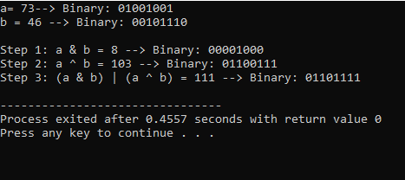

Question 7:

#include <stdio.h>

int main(){

int attendence;

char midterm,feesp;

printf("Please enter your attendence: ");

scanf("%d", &attendence);

printf("the attendence you entered: %d%%\n: ",attendence);

if(attendence<75){

printf("You are not elligible to sit in exam");

}else{

printf("Did you pass midterm exam(F(fail),P(pass): ");

scanf(" %c",&midterm);

if (midterm == 'F' ) {

printf("Sorry, you cannot sit in the final exam (due to failed midterm).\n");

} else {

printf("Have you paid the exam fees? (Y = Yes, N = No): ");

scanf(" %c", &feesp);

if(feesp=='N'){

printf("Your dues are outstanding, please clear your dues to sit in the final exam.\n");

}else{

printf("you are elligible to sit in final exam.\n");

}

}

}

return 0;

}

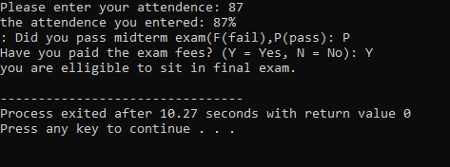

Question 8:

#include <stdio.h>

int main() {

int section, size, quantity;

char type;

float amount = 0.0f, discount = 0.0f, total = 0.0f;

printf("Enter the restaurant section (1: Coffee Shop, 2: Burger Hub, 3: Ice Cream Parlour): ");

scanf("%d", &section);

switch (section) {

case 1: // Coffee Shop

printf("\n--- Coffee Shop ---\n");

printf("Enter the size of coffee (1 = Small, 2 = Medium, 3 = Large): ");

scanf("%d", &size);

// nested if for size → set base price

if (size == 1) {

amount = 200.0f;

} else if (size == 2) {

amount = 300.0f;

} else if (size == 3) {

amount = 400.0f;

} else {

printf("Invalid coffee size!\n");

return 0;

}

printf("Enter the quantity: ");

scanf("%d", &quantity);

printf("Enter the type of coffee (R = Regular, C = Cappuccino, L = Latte): ");

scanf(" %c", &type); // space before %c to ignore newline

// nested if for type

if (type == 'R' || type == 'r') {

printf("Coffee type: Regular\n");

} else if (type == 'C' || type == 'c') {

printf("Coffee type: Cappuccino\n");

} else if (type == 'L' || type == 'l') {

printf("Coffee type: Latte\n");

} else {

printf("Invalid coffee type!\n");

return 0;

}

// total calculation

total = amount \* quantity;

// apply combo if more than 1 coffee

if (quantity > 1) {

printf("Check our combo offers!\n");

discount = 0.10f \* total; // 10% discount

total -= discount;

printf("Combo offer applied! 10%% discount.\n");

}

// final bill

printf("\n--- Final Bill ---\n");

printf("Coffee Size : %s\n", (size == 1) ? "Small" : (size == 2) ? "Medium" : "Large");

printf("Quantity : %d\n", quantity);

printf("Base Price : Rs %.2f\n", amount \* quantity);

printf("Discount : Rs %.2f\n", discount);

printf("Total Bill : Rs %.2f\n", total);

break;

case 2:

printf("Your order will be handled by Burger Hub.\n");

break;

case 3:

printf("Your order will be handled by Ice Cream Parlour.\n");

break;

default:

printf("Invalid section selected!\n");

break;

}

return 0;

}

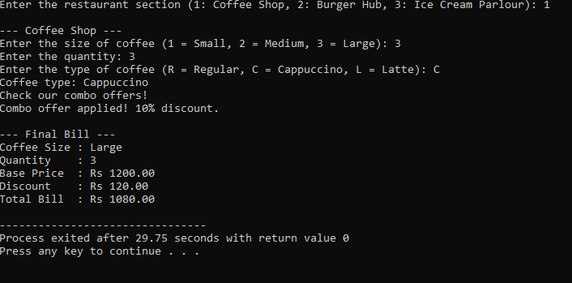

Question 9:

#include <stdio.h>

int main() {

int pin, enteredPin;

int balance = 20000, withdraw; // Initial balance set to 20,000

pin = 6088; // Correct PIN (you can set it to any 4-digit number)

printf("Enter your 4-digit PIN: ");

scanf("%d", &enteredPin);

if (enteredPin == pin) {

printf("Enter withdrawal amount: ");

scanf("%d", &withdraw);

if (withdraw > balance) {

printf("Insufficient Balance\n");

} else {

balance =balance- withdraw;

printf("Withdrawal successful!\n");

printf("Remaining Balance:%d\n", balance);

}

} else {

printf("Incorrect PIN. Access Denied.\n");

}

return 0;

}

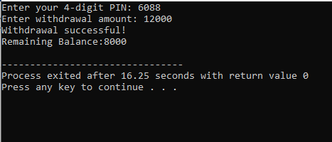

Question 10:

#include <stdio.h>

int main() {

char signal;

int hour, minute;

printf("Enter traffic signal (R, Y, G): ");

scanf(" %c", &signal); // Space before %c to ignore any leading whitespace

printf("Enter current time (HH MM): ");

scanf("%d %d", &hour, &minute);

if (hour < 0 || hour > 23 || minute < 0 || minute > 59) {

printf("Invalid time input.\n");

return 1;

}

// Process based on signal

switch(signal) {

case 'R':

case 'r':

if (hour < 22) {

printf("Stop and wait\n");

} else {

printf("Stop, but night caution allowed\n");

}

break;

case 'Y':

printf("Get Ready\n");

break;

case 'G':

printf("Go\n");

break;

default:

printf("Invalid Signal\n");

break;

}

return 0;

}

